How are podcasts **actually** being used?

Many things you may already be encountering in your day-to-day life, that people are calling podcasts, might not actually be “real” podcasts. This is happening a lot more lately as podcasting finds its place in the world. This identity crisis is not unusual for a “teenage technology” and a teenager it is as its only been around since 2004 (when it was originally known as audio blogging). As you can see from the Google search analysis below, interest in podcasts has **doubled** over the past year or so.

What you are most likely to be encountering as a “podcast” is your favourite radio DJ telling you to listen to their previous shows on their website. The “true” podcasters of the world will be shuddering to hear this as these radio stations and DJs are simply using podcast platforms to manage their archives.

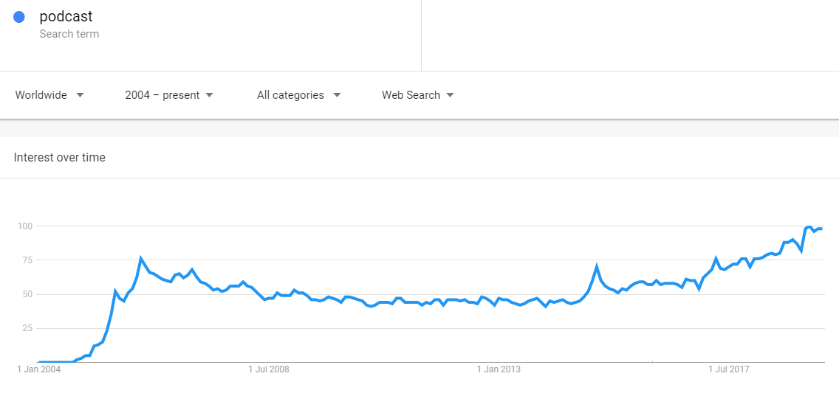

|  |  |  |
| --- | --- | --- |
| Radio Show Archives  As described above | Syndicated Radio Programming  Grounded | FAQs Frequently Asked Questions  Kip McGrath |
| Thought Leadership  On Change | Talent Showcase / Show Reels  Andy Klee | Staff Communication  ????? |
| Conferences (pre- and post-) ????? | Academic White Papers  ????? | Strategic Programming What’s The Point? |
| Entertainment Weekend Party | Book Serialisation Garage Band | Staff Training ????? |
| Deep Dive Conversations Lift As You Rise | Meditation / Spiritualism Emotion in Motion | Group Communication  WiMSA |
| Story Telling  S-Town |  |  |

Opening para

Many things you may already be encountering in your day-to-day life, that people are calling podcasts, might not actually be “real “ podcasts (well according to the purists at least.) This is happening more and more as podcasting finds its place in the world. This identity crisis is not unusual for a “teenage technology” and a teenager it is having only been around since 2004. Originally known as “audio blogging” podcast content and listenership has grown steadily over the years, and recently has started showing exponential growth world-wide.

Perhaps the biggest shift fuelling this massive growth is the beginning of Voice Search Optimisation (VSO) which is rapidly elbowing good ol’ fashioned SEO out. (link this bit to the blog article) VSO is made possible by both Apple and Google transcribing, and indexing, every podcast. That’s right, every single podcast is being automatically turned from voice into text, indexed and then searchable. So, in order to be found in future, you need to be putting the spoken work onto the Internet, and podcasting is by far the most effective way to achieve this.

Below we’ll describe many of the common, effective, and unusual implementations of voice/audio programming that are being utilised by people, companies, non-profits, schools, practically everybody with a story to tell.

Do you have an idea that’s not shown below? We’d love to help you turn it into a reality.

Radio Archive

Pic of piles of CDds or tapes?

At the end of their regular radio show on FM, your favourite DJ is likely to sign-off by reminding you to catch any parts of the show you missed on their website as a podcast. Whilst the “true” podcasters of the world will be shuddering to hear this, it is a useful way to store and archive large volumes of audio content.

FAQs

Pic of someone searching the web while on the phone?

It’s common cause that getting potential clients to spend time on your website reading through loads and loads of content is getting harder and harder to do. Let alone asking them to download a PDF for later reading. The rise of “too long; didn’t read” (**TL;DR)** highlights this and is merely an interim solution. We’re finding that clients really love the ability to craft professionally produced podcast episodes of the most frequently asked questions that potential clients ask. The beauty of presenting these as a podcast channel is that the client is presented with a list of short informative episodes they can listen to in any order, without having to wade through pages and pages. Also, each episode has embedded “calls to action” in them so a client can go from search to listen to clicking on a link without even visiting your website. What we’re finding is that when these new clients make contact, it’s with much more focused “2nd tier” questions.